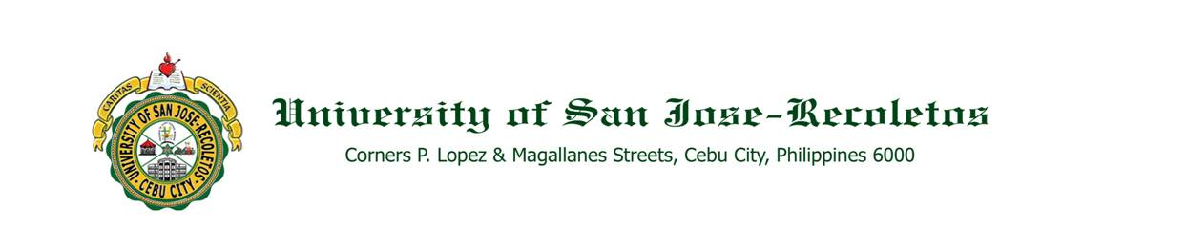

**OFFICE OF THE PRESIDENT**

**TO : ALL CONCERNED** **DATE: October 27, 2020**

**THROUGH : The Deans, Directors, Principals and Office Heads**

**SUBJECT :** **ALL SAINTS DAY & ALL SOULS DAY 2020**

To give the students and employees the opportunity to honor and remember their departed loved ones, classes and work will be suspended on November 2 to 3, 2020 and will resume on November 4, 2020.

As one Josenian family, we join with the Catholic Church in the observance of All Saints Day and All Souls Day during the pandemic.

Thank you. Adelante!

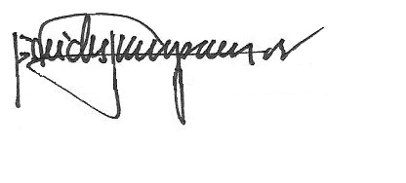

REV. FR. CRISTOPHER C. MASPARA, OAR

President

/bvs